**Project Design Phase-I**

**Solution Architecture**

|  |  |
| --- | --- |
| Date | 06 May 2023 |
| Team ID | NM2023TMID20546 |
| Project Name | Project - CovidVision: Advanced COVID-19 Detection from Lung X-rays with Machine Learning or Deep Learnings |

**Solution Architecture:**

The CovidVision solution architecture is designed to be highly scalable and accessible to hospitals and clinics of all sizes. The architecture consists of four main components: the X-ray image pre-processing module, the deep learning-based COVID-19 detection model, the API interface, and the user interface.

1. X-ray image pre-processing module: The X-ray image pre-processing module is responsible for preparing the chest X-ray images for analysis by the deep learning-based COVID-19 detection model. The pre-processing module involves standardizing and resizing the images to ensure consistency in size and resolution. It also applies noise reduction and contrast enhancement techniques to improve image quality, making it easier for the detection model to identify COVID-19-related patterns in the X-ray images.
2. Deep learning-based COVID-19 detection model: The deep learning-based COVID-19 detection model is the core component of the CovidVision solution architecture. The model has been trained on a large dataset of chest X-rays from COVID-19 patients and healthy patients to accurately identify COVID-19-related patterns in chest X-rays. The model employs state-of-the-art deep learning techniques such as convolutional neural networks (CNNs) to achieve high accuracy in detecting COVID-19 from chest X-rays.
3. API interface: The API interface enables seamless integration of the CovidVision solution into existing hospital and clinic systems. The API provides a simple and secure way to upload chest X-ray images to the detection model and retrieve the COVID-19 detection results. The API is designed to be highly scalable, allowing for the processing of thousands of X-ray images per day.
4. User interface: The user interface is the front-end component of the CovidVision solution architecture, designed to provide an intuitive and easy-to-use interface for healthcare professionals. The user interface allows users to upload chest X-ray images, view the detection results, and provide feedback on the accuracy of the results. The user interface is accessible via a web browser, making it highly accessible to healthcare professionals across different devices.

Overall, the CovidVision solution architecture provides a highly scalable and accurate tool for early COVID-19 detection from chest X-rays. The deep learning-based COVID-19 detection model, coupled with the X-ray image pre-processing module and the API and user interfaces, enables seamless integration into existing hospital and clinic systems, making it a highly accessible and practical solution for early COVID-19 detection.

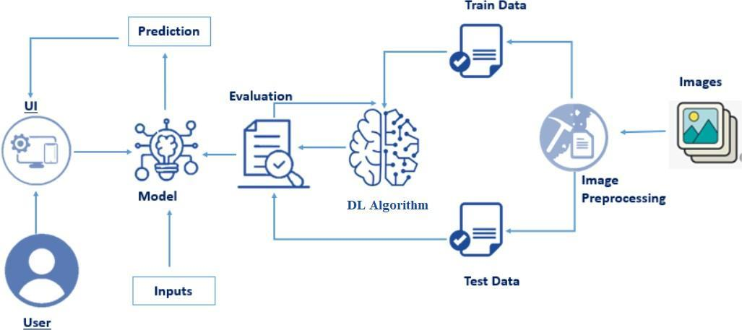

*Figure 1: Architecture and data flow of Deep Learning based detection of COVID-19 from chest X-ray images*

**Reference:** [**https://www.ncbi.nlm.nih.gov/pmc/articles/PMC8286881/**](https://www.ncbi.nlm.nih.gov/pmc/articles/PMC8286881/)